My Fires - Part 4
Zvi Mowshowitz
Parts one through three dealt with almost all of the main deck; only Saproling Burst and Two-Headed Dragon are left and will be dealt with first. After that comes the sideboard, which will conclude the card-by-card analysis.
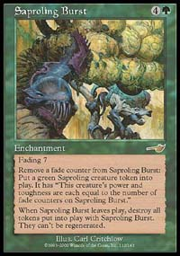
Saproling Burst. Fires of Yavimaya makes everything shine, but it makes this shine a lot more than everything else. With Fires in play, three tokens are usually made (sometimes four, sometimes two, but generally three) and they attack for 12. Then come the normal Burst token attacks. Even without Fires, Burst is a great card. It gets a lot better once all the tricks involved are mastered; if the opponent doesn't know them that's an added bonus. At best, I can give an introduction to them here, although most of them are the same as they've always been. Standard procedure as always is three tokens in most situations. Making more than three requires some reason. Two good ones are needing to block that X creatures (the number of tokens) or die or the opponent being unable to block that many without dying. Other than those it's generally better to stick to a limit of three. The second most common number is two. When the opponent is at 20 and nothing is happening, it's generally better to make two so they can go all the way, especially against a control deck. The main other reason for sticking to two is to make sure they are 4/4 (or 5/5 with Fires). That can be to deal with any number of opposing creatures, with the most common being Kavu Chameleon (game one) and most often Chimeric Idol(s). Only making one creature is reserved for situations where anything smaller would be killed. There are a ton of interactions involving Saproling Burst in this deck and otherwise; the most important thing to remember is not to play a Burst when it won't do any good and to play other creatures first in wars when Fires is not on the table.
Two-Headed Dragon. It's time to bring in the big guy. Who would have guessed that my big tech for a PT would be Two-Headed Dragon? It was Seth Burn who came up with the idea. He came up with the idea while I was at the Magic Invitational. So I got back and suddenly there are eight heads in the deck! It took a moment before I realized he was serious. After testing them, it became clear they were amazing. What does the Dragon do? What doesn't it do? It even double blocks, which is something that should never be mentioned until it actually happens. A lot of players will forget. When it doesn't have to play defense, and it almost never does, it's very difficult to block. Rith gets blocked forever by a lowly Thermal Glider, but almost no one has two of those. In the mirror matchup, it moves from a minor edge for this version (due to size) into a big advantage outside Rhystic Lightning, since if we could stall the Dragon would come and win the game. In other matchups it was similar. When it came out, it just won the game in short order. For a while there were four, then I made it two and two in the sideboard because of mana curve issues - extending the curve to six spreads it pretty thin. Then it came back to three when the sideboard tightened up and I stopped wanting the fourth that much anyway. The Dragon serves a few other purposes. It blocks Blinding Angel, goes over Evil Eye of Orms by Gore (don't laugh, they're out there), it's unaffected by Teferi's Moat and it takes a separate Story Circle to deal with it (since most players will correctly name green against Fires). | 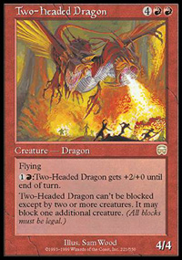  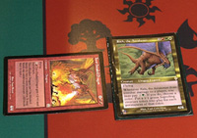  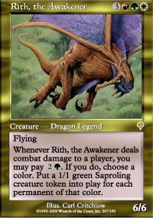 | Rith, The Awakener. Then there's the other dragon. Rith has one big advantage over Two-Headed Dragon, which is that if it deals damage against another green deck the opponent will need a Dragon or a Simoon/Quake to stay in the game. The other advantage is that for the three-color versions, Two-Headed Dragon would be too painful to pump and Rith is actually easier to cast. If the mana isn't there for two heads, then I guess the deck has to go with one. Rith has a lot of issues, though. Its ability is nice but mostly redundant against most non-green decks. It only hits for six damage, which isn't too shabby but not in the Dragon's range. Finally, and this is big, Rith gets blocked! Birds of Paradise buys a turn, Thermal Glider buys a lifetime and even Defiant Falcon keeps hope alive. Rith needs Armadillo Cloak to make its dreams really come true.
Wax and Wane. Fires decks often splash white to play Wax and Wane. Enchantment removal is vital against much of the field, taking out Fires or Burst against other Fires decks and Parallax Wave against rebels or W/G. Against control it goes for Story Circle or Teferi's Moat. The big advantage of Wax and Wane is that it has a perfectly solid second option. Two damage to the opponent is a horrible deal, but if a temporary +2/+2 saves an early mana creature that's great. If it makes a Jade Leech beat up a Blastoderm or a pair of Chimeric Idols that's even better. It almost never goes dead, and even with just four Brushlands backing up Birds of Paradise white mana will be available more often than not.
Aura Mutation. Then there are those who get greedy. Gone is the insurance of a backup ability against decks without enchantments or when no white mana is available. Unlike Wax and Wane, Aura Mutation will be a dead card a significant portion of the time. That's the bad news. The good news is that when Aura Mutation works it is devastating, sufficiently so against other Fires decks that it drove my whole team crazy in testing. Not only does it take out Saproling Burst for only two mana, it creates five bonus 1/1 tokens. The tokens mean that Mutation is never a purely dead card against any deck; a used up or about to be killed Saproling Burst can be turned into five tokens, and sometimes Fires can be turned into three. This gets most annoying when a control player finally gets tired of holding removal and tries to kill one. The bottom line on Aura Mutation turned out to be that it was great but a worse maindeck card than Wax and Wane for W/G decks and for Fires decks. As a sideboard card it suffers because of Simoon and because of opponents playing around it, especially by focusing in on the white mana. It's still worthwhile for those with white mana, but I don't think the white mana is worth it.
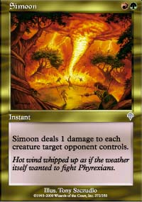
Simoon. Our team missed it for the Pro Tour, but since then it has come to my attention that this is the proper sideboard card for the mirror. There are three basic plans to try and win the mirror matchup. One is Aura Mutation, with the plan being to take out the opponent's Saproling Bursts with a profit, then ride that advantage to victory. That strategy is better than nothing, but misses the point and is often easy to play around. The other two are Simoon and Tangle, both of which are reasonable. Simoon wins out, in large part because it is far more useful against other deck types. It can come in against Rebels, it can come in against W/G, it wrecks blue skies decks the deck would otherwise have no sideboard against. Tangle was basically just for other decks with Blastoderms and Saproling Bursts. Simoon also benefits from opponents continuing to run River Boa and often 'cheating' on the land. If a Dust Bowl version is facing less than 24 lands, Simoon can make mana disruption into plan A. Don't be afraid of "wasting" Simoon on a 1-for-1 trade to mana lock an opponent, but when possible try to get two (or even more) for one with it. I recommend four copies.
Tangle. Tangle is the next best thing to Simoon. Tangle mostly neutralizes Saproling Burst and Blastoderm. Anything else that attacked with them is knocked out cold for two turns. Tangle truly shines when Lumbering Satyr gets involved, but it turns out Satyr is a poor card for both maindeck and sideboard. Tangle is the only way out if one side falls behind in the mirror matchup, and will almost always at least trade for a good offensive card and some time. I prefer to use Simoon and get ahead in the first place. Using Tangle and Simoon together would require too much sideboard space, and there aren't enough cards to take out of the deck anyway. It's vital to keep enough creatures in the deck.
Reverent Silence and Calming Verse. It's no Aura Mutation or Wax and Wane, but without a splash Reverent Silence is the best option for enchantment removal. It trades with a penalty (can't be helped) with Parallax Wave and normally with a penalty with Story Circle. It's pretty rare for Silence to nab multiple enchantments, but it happens. Calming Verse was in Rob's sideboard at the PT, and it's something we considered too. Often there will be a Fires or Burst on the table and killing it is a shame. But being able to cast Silence for free is more important. Two copies seems about right, since it's never clear when they won't be very useful. Too many messes up the ability of the deck to pull a 12 card transformation sometimes.
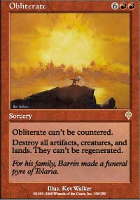
Obliterate. Ka-boom! Blowing up the world has never been so reliable, but it's also rarely been so expensive. Drawing Obliterate before its time is virtually the same as a mulligan until it finally starts to matter. The majority of the time, Obliterate will sit in hand and do absolutely nothing. That by itself is a good reason the deck only uses one in its sideboard. In exchange for that, it will win games no other card could have won. Often it will take a completely and utterly lost game and turn it into one that the opponent cannot win. If it's going to get used, it's vital to be prepared. After the world blows up, the next turn should be Forest (or even better against blue, Karpulsian Forest) and Llanowar Elves or Birds of Paradise. The next turn should be land and Idol, or Port to set up bigger creatures later on. Wait as long as possible before pushing the button. When playing Obliterate, it should basically be ignored as a dead card, with the exception of placing a higher value on the one time tapping of Rishadan Port and Dust Bowl under Tsabo's Web if Obliterate is already in hand. That only changes when the game has gone sufficiently poorly that the plan shifts to Obliterate. At that point, cards are hoarded in hand, lands and mana creatures are carefully rationed and threats are discarded rather than cast to make sure they are not exposed. Be warned, if it gets to that point the opponent will probably know what's coming and likely have a Thwart in reserve.
Flashfires. Crush the rebellion! Or at least take out its basic lands. Flashfires was so popular in Chicago that rebel players splashed blue or even green primarily because it allowed them to play fewer basic Plains. One player even used Tinder Farm because he couldn't find Ruins of Trokair in time! Turned out to be a great choice, because his opponents kept using Rishadan Port on it. That's the best part about using weird lands; opponents don't know there's no reason for them to be in the deck and get scared to death of them. At any rate, Flashfires is an amazing answer to rebel players that play a lot of Plains. It's a poor answer to rebel players that play few basic Plains. Given that the number playing a lot of non-basics should keep going up, Flashfires starts to become much less effective. That makes it more tempting to instead use...
Tsabo's Decree. REALLY crush the rebellion! Not just burn their homes to the ground, but have them all drawn and quartered in public as a warning to the next ten generations that some decks should never be played. Tsabo's Decree is amazing. It has just two problems. One of them is the 5, and one of them is the B. Together they make it very hard to cast. This version of the deck does a great job of getting the 5, but B is hard. Birds of Paradise is a good start. After that comes either City of Brass or Sulphurous Springs. Brian Kibler got away with eight black sources, and to me that's pushing it but I guess it worked. I would consider this to be an 'approved variant' of the deck, using painful lands to get the all powerful Decree. Is it worth the pain? That depends on just how many multicolored rebel decks are out there, and how much the pain and nonbasic status hurt the deck in other matchups. So far, I've been very happy to not suffer those points of pain, but I'm not certain I'm right.

